Name: Mitchell Wadle
Section: 2
University ID: 027779788

Lab 2 Report

Summary:
This lab was all about processes and experimenting with running, viewing , and changing different processes. We started by just viewing a process while it is running and noticing whether or not it is running or sleeping. We then looked at the fork() function and learned how that interacts with the different processes while running. Next, we looked at the wait() function and signals using kill(). Finally we looked at the execve() family of functions and the return value of main().

Overall this lab was very good practice using the terminal and getting comfortable with different commands. This was also good practice with processes and helped us gain a better understanding of how processes interact and run together.

Lab Questions:

3.1:
6pts In the report, include the relevant lines from “ps -l” for your programs, and point out the following items:
- output
- process name
- process state (decode the letter!)
- process ID (PID)
- parent process ID (PPID)

2pts Repeat this experiment and observe what changes and doesn't change.
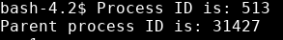Experiment 1

The screen shot above is the output in the terminal after first running the program.
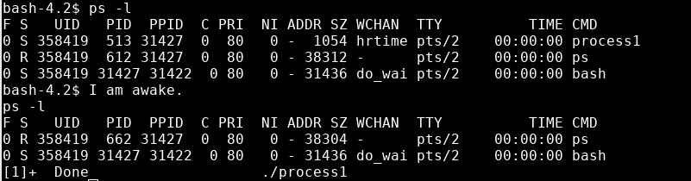
The screen shot above shows the ps -l when the first process is running. From the top of the screen shot, the third line down shows process1.

After the program wakes up and outputs the message “I am awake” the process is no longer visible when you run ps -l.

The name of the process is in the CMD column in the second screen shot and its name is process1.

Looking at the S column you can see that status of the process. It has a letter S which means that the process is sleeping.

The process ID (PID) is in the PID column which for this process is 513.

The parent process ID (PPID) is in the PPID column which for this process is 31427

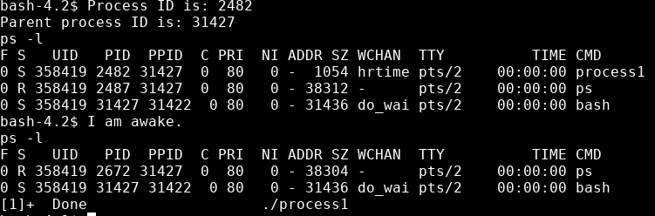
After running the program again I noticed that the only thing that changed is the process ID (PID). Everything else stays the same.

2pts Find out the name of the process that started your programs. What is it, and what does it do?
The Parent process ID (PPID) of process1 is 31427 which is the process ID (PID) of the bash process. This process runs the window where we are running the program.
3.2:
1pt Include the output from the program
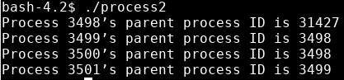

4pts Draw the process tree (label processes with PIDs)
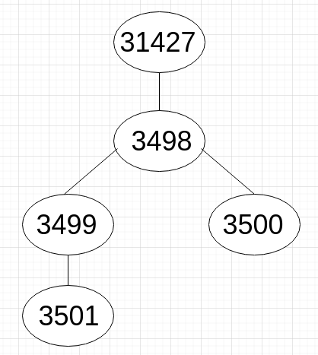
3pts Explain how the tree was built in terms of the program code
2pts Explain what happens when the sleep statement is removed. You should see processes reporting a parent PID of 1. Redirecting output to a file may interfere with this, and you may need to run the program multiple times to see it happen.
The first node is the bash process where the window starts. 3498 is the first process that gets printed out of the program. From this node the tree forks off to multiple nodes with process ID’s of 3499 and 3500. The sleep function in the program lets the next fork just fork off of the first process 3499.
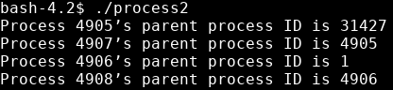

After running the program five times I finally got the parent process ID to go to 1. When you remove the sleep function the program doesn’t leave a reference to the parent so the parent process ID comes back as a 1.

3.3:
2pts Include the (completed) program and its output
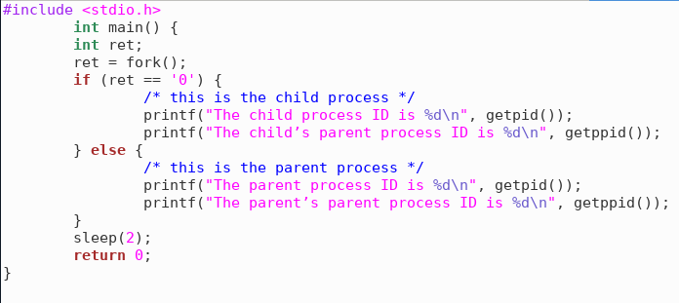
Does a comparison of ret variable. If it is equal to zero then it for the child and if its not then its for the parent.

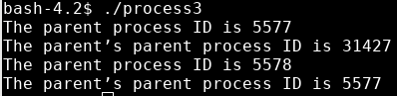
4pts Speculate why it might be useful to have fork return different values to the parent and child. What advantage does returning the child's PID have?
Having the process return the child’s PID allows us to map out how the forks happen in the programs. It allows us to keep track of how the forks effect all of the processes.

3.4:
2pts Include small (but relevant) sections of the output
When the code first starts to run, it alternates between printing the child’s ID and the parent’s ID. Its not a 1:1, sometimes a few children get printed and sometimes a few parents get printed. After running the program a few times I noticed that at the end of the program there is a bunch of outputs left for either the parent or the child. Sometimes it was a bunch of children ID’s and sometimes it was a bunch of parent ID’s.

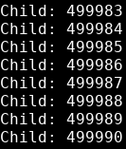

4pts Make some observations about time slicing. Can you find any output that appears to have been cut off? Are there any missing parts? What's going on (mention the kernel scheduler)?
After running for some time the output seems to be just children or just parent ID’s. One of the ID’s is not exactly being cut off but one is completed much faster than the other one. There doesn’t seem to be any missing parts.

3.5:
6pts Explain the major difference between this experiment and experiment 4.
Be sure to look up what wait does (man 2 wait).
The major difference between experiment 4 and the experiment just done is that the previous experiment alternated printing out the parent and children ID’s where as this program prints out all of the child ID’s then all of the parent ID’s.

3.6:
2pts The program appears to have an infinite loop. Why does it stop?
4pts From the definitions of sleep and usleep, what do you expect the child's count
The kill() function in the else part of the if-else statement is running and when the child and the SIGTERM are right then the process is killed and the messages are printed.
to be just before it ends?
2pts Why doesn't the child reach this count before it terminates?
The count should be right around 975.
It is at this count where the child variable moves from a zero to an ID so the kill() function happens

3.7:
8pts Read the man page for execl and relatives (man 3 exec). Under what conditions is the printf statement executed? Why isn't it always executed?
(consider what would happen if you changed the program to execute something other than /bin/ls.)
Printf statement executes when there is a pointer to filename for execution and when the pointer is casted as NULL.
If the conditions are not met then the printf will be unable to print.
3.8:
2pts What is the range of values returned from the child process?
2pts What is the range of values sent by child process and captured by the parent process?
Ranges from 0 to 233
2pts When do you think the return value would be useful?
The signal return always came back as 15
Hint: look at the commands true and false.
When the return value is a signal and not a status.

